SMARTCROP ADVISOR: PREDICTIVE CROP RECOMMENDATION & AGRO-MANAGEMENT SYSTEM USING RANDOM FOREST

ABSTRACT
Agriculture plays a vital role in ensuring food security, yet farmers often face challenges in selecting the most suitable crops due to unpredictable climatic conditions, soil variability, and inefficient use of fertilizers. Traditional decision-making is largely experience-driven, which may lead to reduced yield and economic loss. The need for intelligent, data-driven solutions is therefore crucial in modern agro-management. This project, SmartCrop Advisor Predictive Crop Recommendation & Agro-Management System using Random Forest, addresses this gap by leveraging machine learning techniques to provide personalized crop recommendations. The system integrates soil parameters such as Nitrogen, Phosphorus, Potassium, pH, rainfall, temperature, and humidity, processes them using the Random Forest algorithm, and predicts the most suitable crop for cultivation. A Django-based web platform is developed to make the system user-friendly and accessible to both farmers and agricultural experts. The proposed solution empowers farmers with data-driven insights, enhancing productivity, profitability, and sustainability in agriculture.
Keywords: Crop Recommendation, Agro-Management, Random Forest, Machine Learning, Django, Agriculture, Precision Farming.

EXISTING SYSTEM
In the existing agricultural practices, crop selection is primarily guided by traditional methods where farmers rely on intuition, ancestral knowledge, and past experiences rather than scientific analysis. These approaches often fail to account for dynamic environmental changes such as irregular rainfall, fluctuating temperatures, and varying soil fertility, leading to inconsistent yields. Additionally, some research has introduced predictive models like Support Vector Machines (SVM), K-Nearest Neighbors (KNN), Decision Trees, and Naïve Bayes classifiers for crop recommendation and prediction. While these models provide a degree of automation, they often struggle with scalability, feature complexity, and accuracy in heterogeneous agricultural datasets. Many existing systems also lack integration with real-time data sources, making them less practical for farmers who require timely and localized recommendations.

DISADVANTAGES
- Traditional methods are highly subjective and inconsistent.
- Existing ML models often provide limited accuracy with complex agro-data.
- Lack of scalability and adaptability to diverse climatic zones.
- Absence of real-time data integration for timely recommendations.
- Limited usability and accessibility for farmers due to complex interfaces or technical barriers.

PROPOSED SYSTEM
The proposed system, SmartCrop Advisor – Predictive Crop Recommendation & Agro-Management System using Random Forest, introduces an intelligent, data-driven framework to overcome the limitations of traditional agricultural practices and earlier machine learning models. Unlike manual methods and non-robust algorithms, this system leverages Random Forest, a powerful ensemble-based classifier, to recommend the most suitable crops based on soil nutrients (N, P, K), temperature, humidity, pH, and rainfall. The system is integrated with a Django-based web platform, allowing administrators to manage datasets, preprocess agricultural data, train the model, and monitor accuracy. Farmers and end-users can easily input environmental parameters and receive not only accurate crop recommendations but also detailed agro-management guidelines such as soil health practices, fertilizer usage, pesticide safety, precautions, and marketing advice.

ADVANTAGES
- High Accuracy & Robustness – Random Forest improves prediction reliability compared to single classifiers, reducing errors in crop recommendation.
- Automation of Data Handling – Preprocessing, training, and prediction are automated, eliminating manual workload and human errors.
- Comprehensive Agro-Advisory – Along with crop suggestions, the system provides soil health, fertilizer, pesticide, and market guidance.
- User-Friendly Web Platform – Built on Django, it allows easy registration, login, and interaction for both administrators and farmers.
- Overcomes Traditional Limitations – Addresses challenges of subjective decision-making, poor scalability, and limited predictive capacity in earlier methods.

SYSTEM ARCHITECTURE
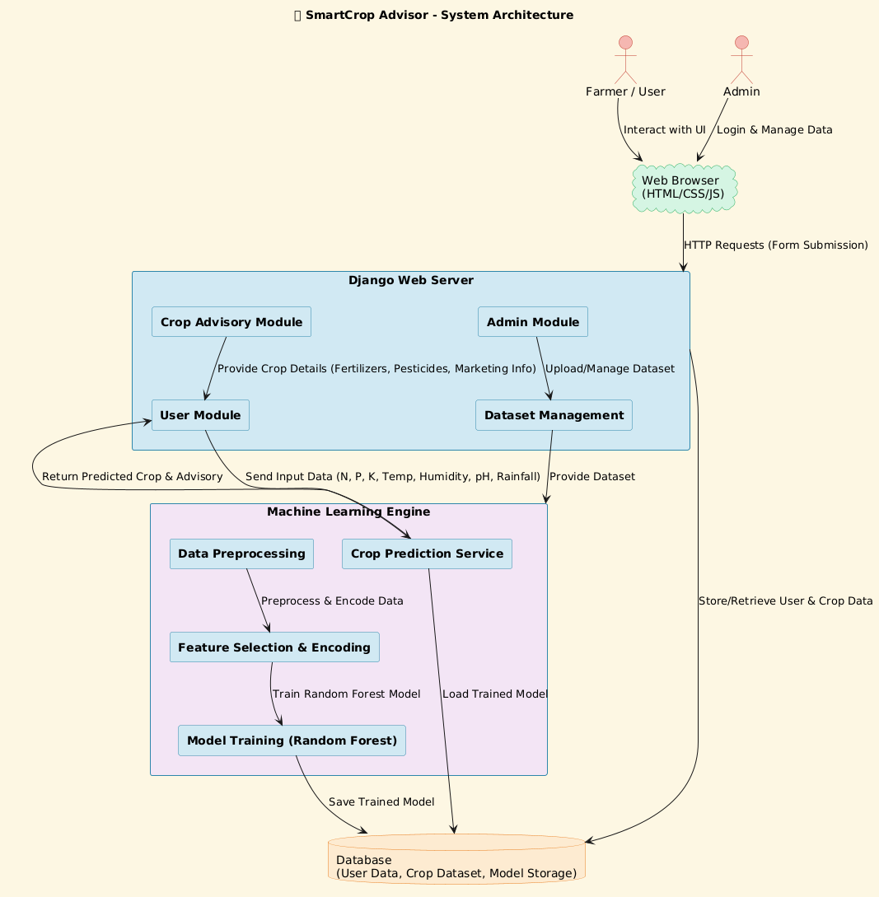
System Architecture

SYSTEM REQUIREMENTS
H/W SYSTEM CONFIGURATION:
- RAM - 4 GB (min)
- Hard Disk - 20 GB
- Key Board - Standard Windows Keyboard
- Mouse - Two or Three Button Mouse
- Monitor - SVGA

SOFTWARE REQUIREMENTS:
- Operating system : Windows 7 Ultimate.
- Coding Language : Python.
- Back-End : Django-ORM
- Designing : Html, css, javascript.
- Data Base : MySQL / (WAMP Server).

